Overview

This document provides a detailed, comparative analysis of **five** major **public** and **restricted** datasets essential for **Vision-Language Model (VLM)** development in chest radiography: **IU-XRay, MIMIC-CXR, CheXpert Plus, ReXGradient-160K, and PADCHEST.**

The objective of this document is to **systematically** collect and present critical metadata for each dataset across the following parameters:

* Size of the dataset (no. of XRAYs and their assigned reports)
* No. of unique patients
* Credentialed or not / if yes can we use it commercially and how we get the approval
* Original source and brief paragraph about how it was collected
* Structure (how to read and process the data) / metadata
* One view or more than one view
* Body parts distribution across the dataset
* Label structure (e.g. free text, impressions…etc)
* Sample of the data (patient - Xrays and its assigned report)

IU-XRay

**Size of the dataset and No. of unique patients:**

The dataset contains **7,470 chest X-ray images** and **3,955 radiology reports**. These 3,955 reports correspond to **3,955 unique patients**.

**Credentialed or not / Commercial use:**

**License:** Creative Commons Attribution-NonCommercial-NoDerivatives 4.0 International License(<https://creativecommons.org/licenses/by-nc-nd/4.0/>)

**Possible violation:**

NonCommercial — You may not use the material for commercial purposes

CC’s NonCommercial (NC) licenses prohibit uses that are “primarily intended for or directed toward commercial advantage or monetary compensation.”

**Original source and collection method:**

With IRB approval (OHSRP# 5357), the **Indiana University (IU)** investigators pulled narrative chest x-ray reports for posterior–anterior (PA) chest x-ray examinations from 2 large hospital systems within the Indiana Network for Patient Care10 database.

**Structure, Metadata, and Label Structure:**

Images are available in **PNG** and **DICOM** formats. The reports (labels) are **free-text XML files**. The XML files contain the metadata and are structured with key fields, including INDICATION, FINDINGS, and IMPRESSIONS.

**One view or more than one view & Body parts distribution:**

The dataset includes **more than one view** (specifically, **frontal (PA) and lateral views**) for each study. The entire dataset consists of **chest** X-rays.

**Sample of the data:**

Kaggle mirror:

**Uid:** 1000

**MeSH:** Opacity/lung/upper lobe/right;Pulmonary Atelectasis/upper lobe/right;Opacity/lung/lingula

**Problems:** Opacity;Pulmonary Atelectasis;Opacity

**Image:** PA and lateral chest x-XXXX XXXX.

**indication:**  XXXX-year-old male, XXXX.

**Comparison:** XXXX PA and lateral chest radiographs.

**Findings:** There is XXXX increased opacity within the right upper lobe with possible mass and associated area of atelectasis or focal consolidation. The cardiac silhouette is within normal limits. XXXX opacity in the left midlung overlying the posterior left 5th rib may represent focal airspace disease. No pleural effusion or pneumothorax. No acute bone abnormality.

**Impression:** 1. Increased opacity in the right upper lobe with XXXX associated atelectasis may represent focal consolidation or mass lesion with atelectasis. Recommend chest CT for further evaluation. 2. XXXX opacity overlying the left 5th rib may represent focal airspace disease.

Projection:

1000 1000_IM-0003-1001.dcm.png Frontal

1000 1000_IM-0003-3001.dcm.png Frontal

1000 1000_IM-0003-2001.dcm.png Lateral

**1001 3001**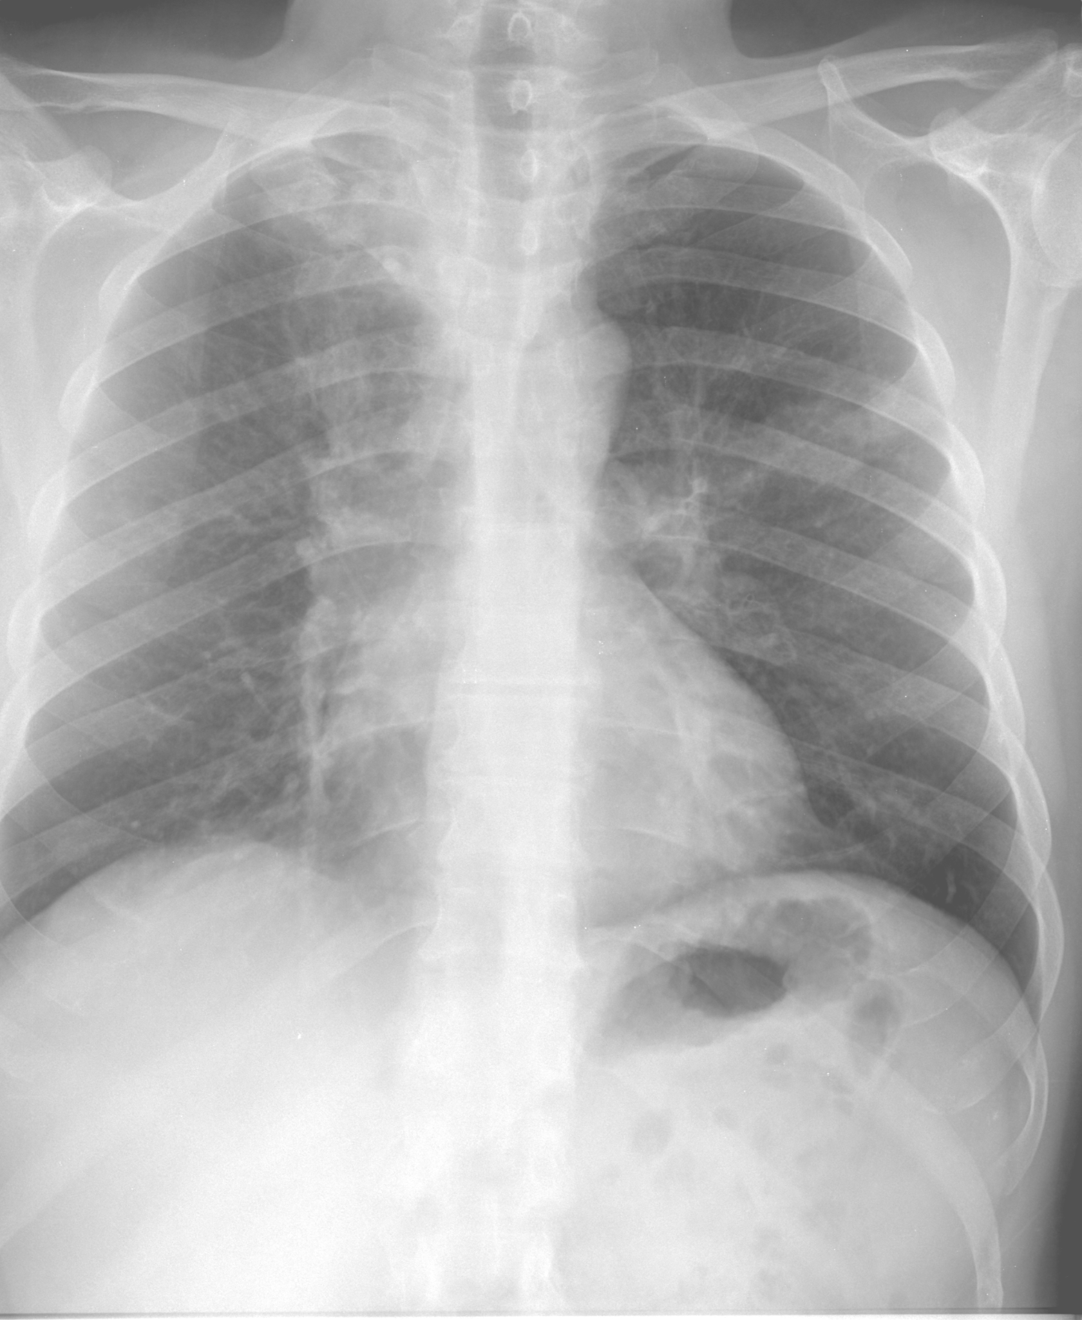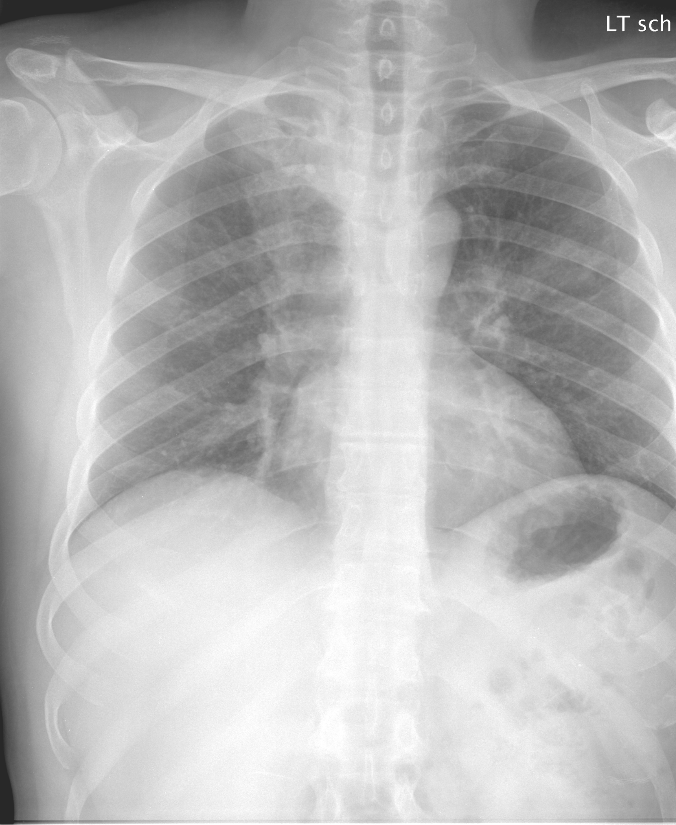

**2001**

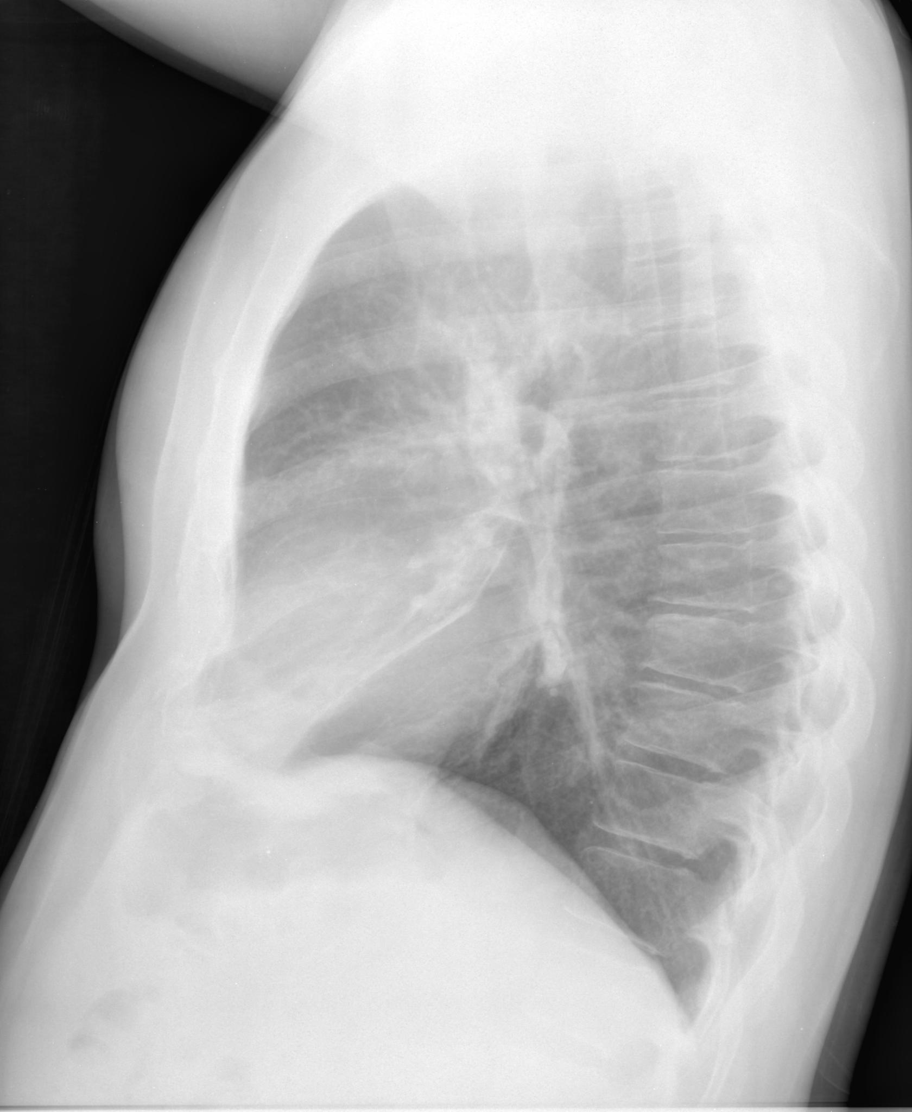

Academic Paper: <https://pmc.ncbi.nlm.nih.gov/articles/PMC5009925/>

Kaggle Dataset Mirror: <https://www.kaggle.com/datasets/raddar/chest-xrays-indiana-university>

Main dataset page: <https://openi.nlm.nih.gov/>

MIMIC-CXR

**Size of the dataset and No. of unique patients:**

The dataset contains **377,110 chest X-ray images** which are associated with **227,835** radiology reports corresponding to **65,379 unique patients**.

**Credentialed or not / Commercial use:**

This is a **credentialed** dataset. To access it, you must become a credentialed user on PhysioNet. This involves completing the "Data or Specimens Only Research" training course from the CITI Program and signing the **Data Use Agreement (DUA)**.

**NOTE: commercial use is not permitted**

**Original source and collection method:**

**Original Source:** Beth Israel Deaconess Medical Center (BIDMC) in Boston, MA.

**Collection Method:** The data was collected as part of routine clinical care for patients in the emergency department and hospital inpatients between 2011 and 2016. All images and reports were de-identified in accordance with the Health Insurance Portability and Accountability Act (HIPAA) Safe Harbor provisions.

**Structure, Metadata, and Label Structure:**

**Structure:** The dataset is organized by patient (subject_id) and study (study_id)**.**

**Reports:** Reports are provided as free-text files (.txt)

**Metadata:**

* **cxr-record-list.csv.gz:** A complete inventory of all DICOM images, mapping each image to its corresponding study and patient ID.
* **cxr-study-list.csv.gz:** A complete inventory of all studies, mapping each study ID to its corresponding patient ID.
* **cxr-provider-list.csv.gz:** Links every study to de-identified medical staff IDs (ordering physicians, attending physicians, and residents). These IDs are consistent with the MIMIC-IV dataset.
* **mimic-cxr-reports.zip:** A standalone compressed archive containing all the text reports. This allows users to access the reports quickly without navigating through individual patient image folders

**One view or more than one view & Body parts distribution:**

The dataset contains more than one view. A csv file is responsible for mapping each image with the ViewPosition, which most commonly includes AP (anterior-posterior), PA (posterior-anterior), and LAT (lateral)**.**

The dataset is exclusively focused on the chest

**Sample of the data:**

Report example:

FINAL REPORT

EXAMINATION: CHEST (PA AND LAT)

INDICATION: ___ year old woman with ?pleural effusion // ?pleural effusion

TECHNIQUE: Chest PA and lateral

COMPARISON: ___

FINDINGS:

Cardiac size cannot be evaluated. Large left pleural effusion is new. Small

right effusion is new. The upper lungs are clear. Right lower lobe opacities

are better seen in prior CT. There is no pneumothorax. There are mild

degenerative changes in the thoracic spine

IMPRESSION:

Large left pleural effusion

From: <https://mimic.mit.edu/docs/iv/modules/cxr/>

Main dataset page: <https://physionet.org/content/mimic-cxr/2.1.0/>

Project website: <https://mimic-cxr.mit.edu/>

CheXpert Plus

**Size of the dataset and No. of unique patients:**

The dataset contains **223,462 unique pairs** of radiology reports and chest X-ray images, which come from **187,711 studies** from **64,725 patients.**

**Credentialed or not / Commercial use:**

**License:** Stanford University Dataset Research Use Agreement

**Link:** [Stanford AIMI Shared Datasets](https://stanfordaimi.azurewebsites.net/datasets/5158c524-d3ab-4e02-96e9-6ee9efc110a1)

**Credentialed/Access**: Access is restricted. You must register on the Stanford AIMI website and agree to the **Stanford University Dataset Research Use Agreement** to download the data.

**Commercial Use**: Permission is granted to view and use the CheXpert Plus Dataset without charge for personal, non-commercial research purposes only. Any commercial use, sale, or other monetization is prohibited.

**Original source and collection method:**

**Original Source:** Stanford Health Care (Stanford University Medical Center).

**Collection Method**: The dataset builds upon the original CheXpert collection (exams from Oct 2002–July 2017). For the "Plus" version, researchers went back to the original source to retrieve the **full text radiology reports** and **DICOM images** that were previously withheld or downsampled.

**Structure, Metadata, and Label Structure:**

**Structure: The dataset includes:**

* **Images:** Provided in both DICOM (preserving 47 metadata tags) and PNG formats.
* **Reports:** Provided as text, parsed into up to 11 structured sections (e.g., History, Findings, Impression, Technique).
* **Metadata Files:** csv files links images to patients, studies, and includes the demographic data.

**Class Labels**: It retains the **14 observation labels** (Positive, Negative, Uncertain, Blank) from the original CheXpert/CheXbert labelers.

**RadGraph**: It adds **RadGraph annotations**, which are detailed knowledge graphs connecting entities (e.g., "lung") with relations (e.g., "located at") for fine-grained analysis.

**One view or more than one view & Body parts distribution:**

The dataset contains **more than one view**. Like the original, it includes both **Frontal** and **Lateral** views for many studies.The dataset is exclusively focused on the **chest.**

**Sample of the data:**

None publicly available

GitHub Repo: <https://github.com/Stanford-AIMI/chexpert-plus>

Main dataset page: [Stanford AIMI Shared Datasets](https://stanfordaimi.azurewebsites.net/datasets/5158c524-d3ab-4e02-96e9-6ee9efc110a1)

Academic paper: <https://arxiv.org/pdf/2405.19538>

ReXGradient-160K

**Size of the dataset and No. of unique patients:**

**Number of Reports (Studies):** 160,000 radiological studies.

**Number of X-Rays:** 273,004 images

**Number of unique patients:** 109,487

**Credentialed or not / Commercial use:**

The dataset is open-sourced at huggingface.

**Original source and collection method:**

**Original Source:** The original data source is **Gradient Health**

**Collection Method:** The data was aggregated from **3 distinct U.S. health systems** comprising **79 medical sites** (including hospitals, clinics, and offices). This multi-site collection strategy ensures high diversity in image quality, patient demographics, and equipment manufacturers, helping AI models generalize better than single-hospital datasets.

**Preprocessing:** Original DICOMs were converted to PNG format. Images were downsampled to **25%** of original dimensions for the public release (original high-res DICOMs are available commercially).

**Structure, Metadata, and Label Structure:**

* **File Format:**
  + **Images:** PNG format.
  + **Reports/Metadata:** JSON or CSV files
* **Metadata Fields:**
  + PatientID
  + AccessionNumber (Study ID)
  + PatientSex, PatientAge, PatientWeight
  + EthnicGroup
  + StudyDate
  + InstitutionName (anonymized site ID)
  + Manufacturer (X-ray machine brand)
  + ViewPosition (PA, AP, Lateral)

### **Body Parts Distribution**

* + **Chest Only.**
  + The dataset is exclusively composed of **Chest Radiographs (CXRs)**.

### **Label Structure (Reports)**

The "labels" are **free-text radiology reports**. They follow a standard four-section clinical structure:

1. **Indication:** Why the exam was ordered (ex:, "Shortness of breath").
2. **Comparison:** References to prior exams.
3. **Findings:** Detailed observations of the image (the core "labels").
4. **Impression:** The radiologist's summary diagnosis.

**Sample of the data:**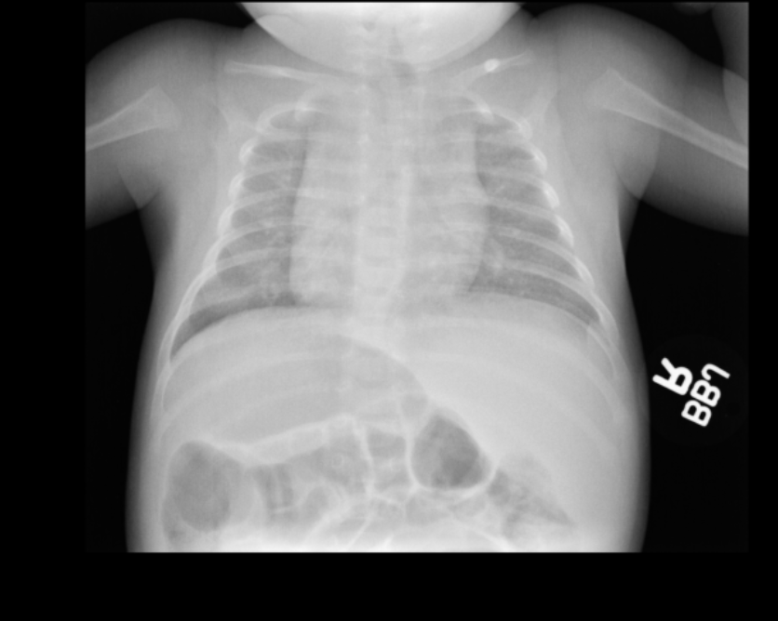

| **Field** | **Value** |
| --- | --- |
| **id** | pGRDNLZHK1CJMB9DS_aGRDNLD4ATLU63FN8_s1.2.826.0.1.3680043.8.498.98869902613028373370176585666602171978 |
| **AccessioNumber** | GRDNLD4ATLU63FN8 |
| **StudyInstanceUid** | 1.2.826.0.1.3680043.8.498.98869902613028373370176585666602171978 |
| **PatientSex** | M |
| **Patient Age** | 007Y (7 Years Old) |
| **Study Date** | 20100722 (July 22, 2010) |
| **Study Description** | DG CHEST 2V |
| **Indication** | Cough, fever |
| **Comparison** | null |
| **Findings** | No active infiltrate or effusion is seen. Only mild peribronchial thickening is noted. The heart is within normal limits in size. No bony abnormality is seen |
| **Impression** | No pneumonia. Mild peribronchial thickening. |

Main dataset page[: https://huggingface.co/datasets/rajpurkarlab/ReXGradient-160K](https://huggingface.co/datasets/rajpurkarlab/ReXGradient-160K)

Academic paper: <https://arxiv.org/abs/2505.00228>

PADCHEST

**Size of the dataset and No. of unique patients:**

Data consists of 160,868 chest X-ray images and 109,931 reports.

**67,625 unique patients**.

**Credentialed or not / Commercial use:**

Public dataset.

**Original source and collection method:**

**Original Source**: **Hospital Universitario de San Juan**, Alicante (Spain).

**Collection Method**: The dataset comprises studies interpreted and reported by 18 radiologists at the hospital from **January 2009 to December 2017**. The images and reports were anonymized and de-identified by the Medical Image Bank of the Valencian Community (BIMCV).

**Labeling**: A subset (27%) was manually annotated by trained physicians, and the remaining reports were automatically labeled using a Recurrent Neural Network with attention mechanisms (RNN-ATT) trained on the manual set.

**Structure, Metadata, and Label Structure:**

**Structure**: The dataset includes **image files** (1 TB) and a **CSV file** with 33 fields for each study.

**Images**: Provided in **DICOM** format and **PNG**.

**Metadata**: The CSV file contains standard DICOM fields and derived fields (e.g., Labels, MethodLabel, Report).

**Language**: This is the first large-scale dataset to contain radiographic reports in **Spanish**.

**Free Text**: The dataset includes the source **radiology reports in Spanish** (field Report).

**Structured Labels**: Reports are labeled with **standardized medical codes** mapped to the **UMLS (Unified Medical Language System)** terminology.

**Hierarchy**: The labels are organized into three hierarchical taxonomies:

1. **Radiographic Findings** (174 labels, e.g., "infiltrates", "pacemaker").
2. **Differential Diagnoses** (19 labels, e.g., "pneumonia", "COPD").
3. **Anatomical Locations** (104 labels, e.g., "upper lobe", "right").

**Method**: Labels are marked as either manually extracted (Physician) or automatically extracted (RNN_model).

**One view or more than one view & Body parts distribution:**

**Information**: The dataset contains **more than one view**.

**Details**: It covers **six different position views**. The main projections are **PA** (Postero-Anterior), **L** (Lateral), **AP** (Antero-Posterior) vertical/supine, **Lordotic**, and **Rib** views.

The dataset is exclusively focused on the **chest**.

**Sample of the data:**

<https://www.kaggle.com/datasets/raddar/padchest-chest-xrays-sample?select=chest_x_ray_images_labels_sample.csv>

Academic paper: <https://arxiv.org/pdf/1901.07441>

Source website: <https://bimcv.cipf.es/bimcv-projects/padchest/>